CE 5364 Groundwater Transport Phenomena March 8, 2005

MODFLOW/MODPATH/MOC3D Project

First Handout

A plume of dissolved trichloroethylene has been found in a shallow unconfined aquifer. The distribution of the plume is shown on the figure on the following page. The shallow aquifer is the top of a three-layered system as shown in the figure below. An aquitard separates the unconfined aquifer from a lower leaky confined aquifer.

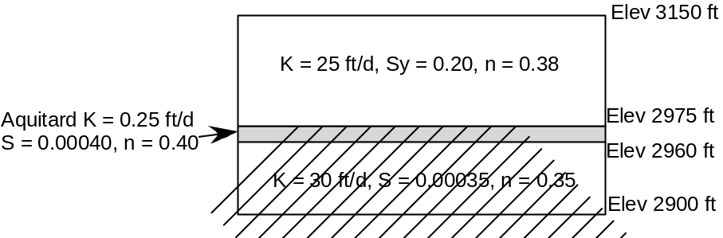

Three domestic wells exist down-gradient of the plume. Wells 1 and 3 are in the upper aquifer, while well 2 is in the lower aquifer. They each flow at 120 gpm.

Task 1. Set up the MODFLOW files and perform a steady-state run with representing the hydraulic conditions as described. That result will provide a initial head array for later runs.

Task 2. Use MODPATH to demonstrate the advective movement of the plume under the steady-state conditions. Consider particle transport in all 3 layers.

